Date | 2024/02/07
Module | 3CQT
Type | TP
State | Ready

Human history and games are inextricably intertwined. For millennia, people have held an innate compulsion to play, and that won’t change anytime soon. What they needed, they innovated, leaving us a wealthy legacy of devices through the centuries, ranging from the basic but powerful wonder of dice to the timeless strategizing involved in chess, and on up to a library of latter-day board games that run the gamut in their levels of sophistication. If you’ve got an understanding the evolution of games, you can begin to make intelligent choices about what elements of games you might want to include in your gamification designs.

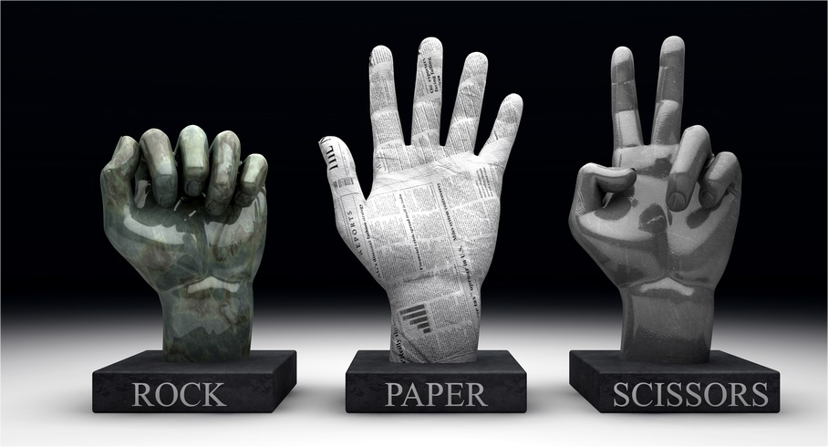

Introduction

Your company wants to reintroduce a their number one selling game and release this year.
An interne was given the task to write the first prototype, but your company realized it was a bad idea. As the game is not well written and hard to understand. Being you’ve experience in writing quality code, you have been given the task to make the program readable by following the best practices of Python, make it conform to the current standard and translate it completely into English.
The source code can be found in a zip file rock_paper_scissors.zip provide with this document.
You can use linters, formatters, and code analysis tools to help you in your task.

Summary

The game works as the following:
- When the game is launched, it ask you which make choice between rock, paper, and scissors.
- After your input the game will then let it’s AI make a choice
- The game will then call out the winner and if the AI wins against the player the game will end.

Subject

Delivery (1 point)
- You must deliver your file as such name_surname_rock_paper_scissors.zip (Your file should be zip format no other format allowed)
example paul_deguerre_rock_paper_scissors.zip .
Comment code (1 points)
- The program must be commented.

Refactor code (4 points)
- Use global variable and constant if needed.
- Translate functions and variables in English.
- Use functions to structure your code.
- Protect code from bad entry from the user.

Respect all the standards (4 points)
- Make the code compliant with PEP8, PEP257, PEP484, PEP526, & PEP3101
- Make your code follow the SOLID principle.
- Make use of Pylint and get a score of 10/10
Unit Test & Code Coverage (5 points)
- Write unit test using PYTEST and verify you have 100% code coverage.
Bonus (5 points)
- Enrich the current application to provide more functionalities, always having a code respecting the required code qualities and having 100% test coverage.

Rules

This project must be your creation and done by your own. Plagiarism or copy / past are forbidden and will result of a 0.

⚠ File extension should be strictly respected. If you deliver file in a different format than expected, the file will be entirely discarded.

